UNIT 12
STRUCTURES
1.- Tension
* Read the information about Tension that you will find in the following web address. Attention! Do not answer the questionnaire at the bottom of the page.
http://www.tecno12-18.com/eng/mud/forces1/forces1.asp?link=&lengua=
* Complete the following test. Repeat it as many times as necessary until you don't have any errors: http://www.tecno12-18.com/eng/mud/forces1/test/test.asp
* Return to the page http://www.tecno12-18.com/eng/mud/forces1/forces1.asp?link=&lengua= and answer the questionnaire at the bottom of the page..

2.- Compression.
* Read the information about Compression that you will find in the web address below. Attention! Do not answer the questionnaire at the bottom of the page.
http://www.tecno12-18.com/eng/mud/forces2/forces2.asp
* Complete the following test. Repeat it as many times as necessary until you don't have any errors: http://www.tecno12-18.com/eng/mud/forces2/test/test.asp
* Return to the page http://www.tecno12-18.com/eng/mud/forces2/forces2.asp and answer the questionnaire at the bottom of the page.

3.- Bending.
* Read the information about Bending that you will find in the web address below. Attention! Do not answer the questionnaire at the bottom of the page.
http://www.tecno12-18.com/eng/mud/forces3/forces3.asp
* Complete the following test. Repeat it as many times as necessary until you don't have any errors: http://www.tecno12-18.com/eng/mud/forces3/test/test.asp
* Return to the page http://www.tecno12-18.com/eng/mud/forces3/forces3.asp and answer the questionnaire at the bottom of the page.

4.- Shear force.
* Read the information about Shear Force that you will find in the web address below. Attention! Do not answer the questionnaire at the bottom of the page.
http://www.tecno12-18.com/eng/mud/forces4/forces4.asp
* Complete the following test. Repeat it as many times as necessary until you don't have any errors: http://www.tecno12-18.com/eng/mud/forces4/test/test.asp
* Return to the page http://www.tecno12-18.com/eng/mud/forces4/forces4.asp and answer the questionnaire at the bottom of the page.

5.- Torsion.
* Read the information about Torsion that you will find in the web address below. Attention! Do not answer the questionnaire at the bottom of the page.
http://www.tecno12-18.com/eng/mud/forces5/forces5.asp
* Complete the following test. Repeat it as many times as necessary until you don't have any errors: http://www.tecno12-18.com/eng/mud/forces5/test/test.asp
* Return to the page http://www.tecno12-18.com/eng/mud/forces5/forces5.asp and answer the questionnaire at the bottom of the page.

3.- Construction of a cardboard shelf.
We are going to build it following the steps that you can see below. You have to present a project like the one presented as an example.
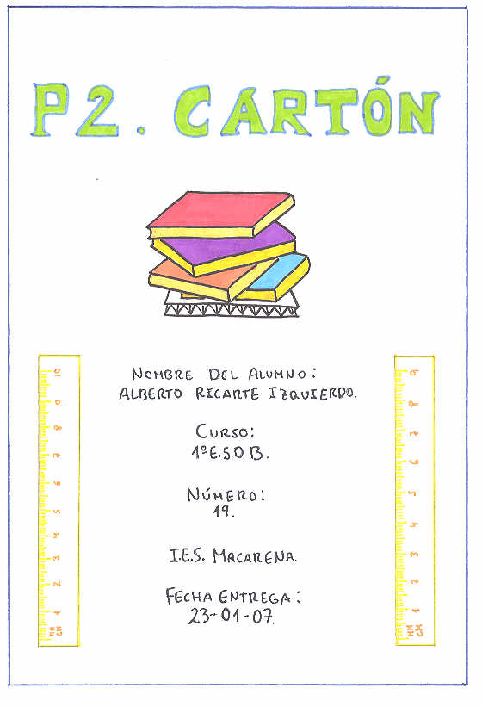

Index
- Materials
- Process
- Plan 1. Side view of cadboard.
- Plan 2. Detail of side view of cardboard.

Materials
QUANTITY | MATERIAL
4 | A4 page
1 | Pencil
1 | Stick of glue
1 | Rubber
1 | Ruler
1 | Set-square
1 | Triangular set-square
1 | Scissors

Process
- Put the A4 page flat on the table.
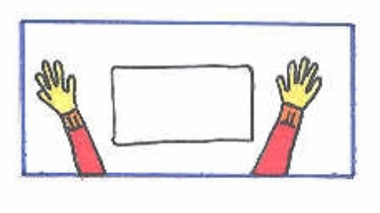
- Divide the page into columns of equal width (approx 2cm) and using the set squares, draw parallel lines to divide up the page.
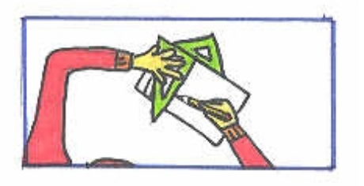
- When the page is completely divided, fold the first column along the first parallel line.
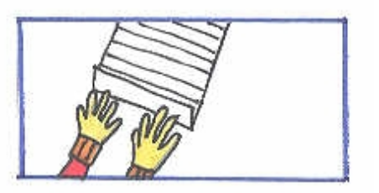
- Continue by folding the second column in the opposite direction to the first. Continue in this way until the A4 page is completely folded like an accordion.
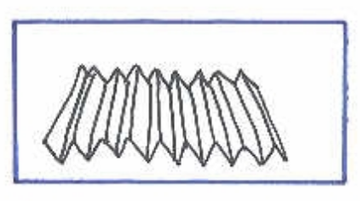
- Fold another A4 page in the same way and join both of them together by gluing the first columns together forming a single piece.
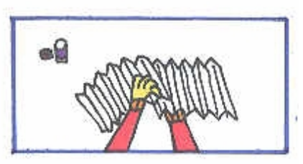
- Adapt the accordion’s shape to measure 29.7cm in length. Then, stick an A4 sheet on the top and bottom of the accordion shape.
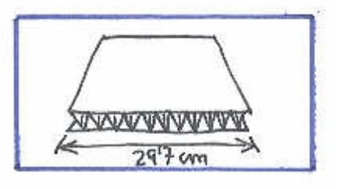
- To test the resistance of the structure, place books on top.

Plan 1. Side view of cardboard
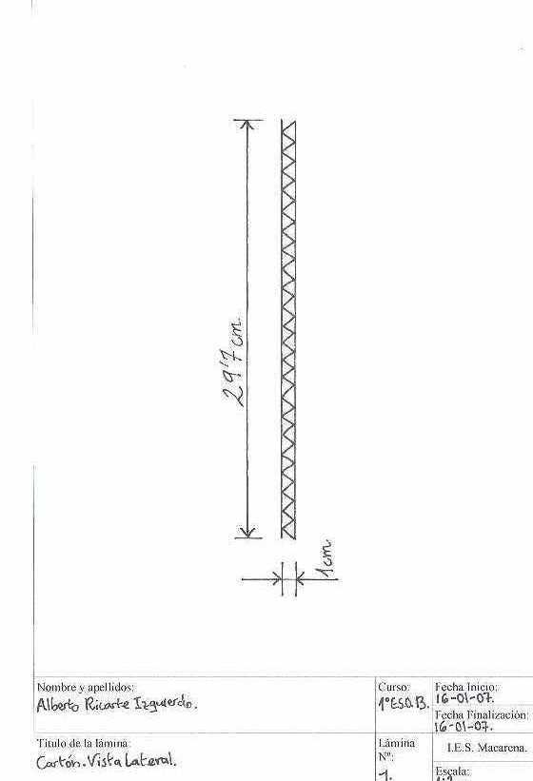

Plan 2. Detail of side view of cardboard.
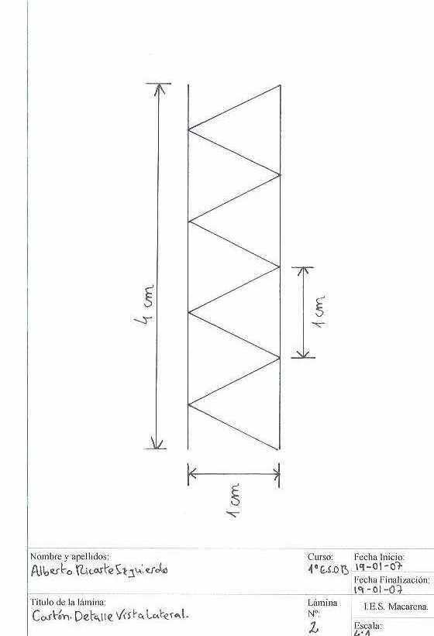

Another example:

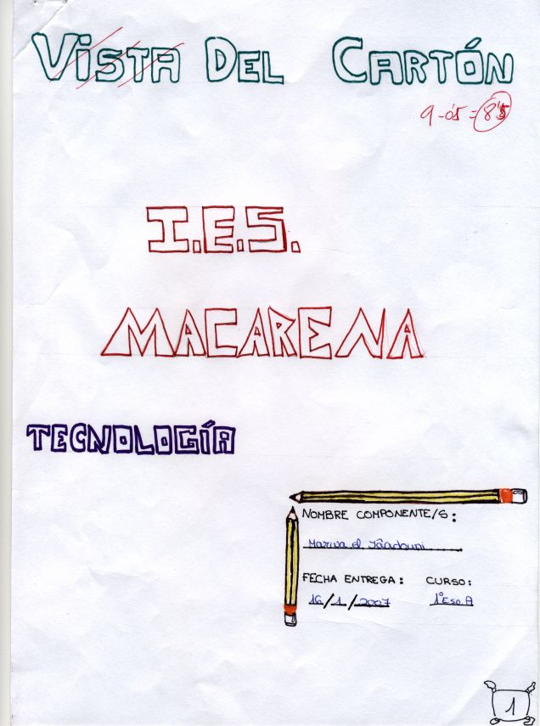
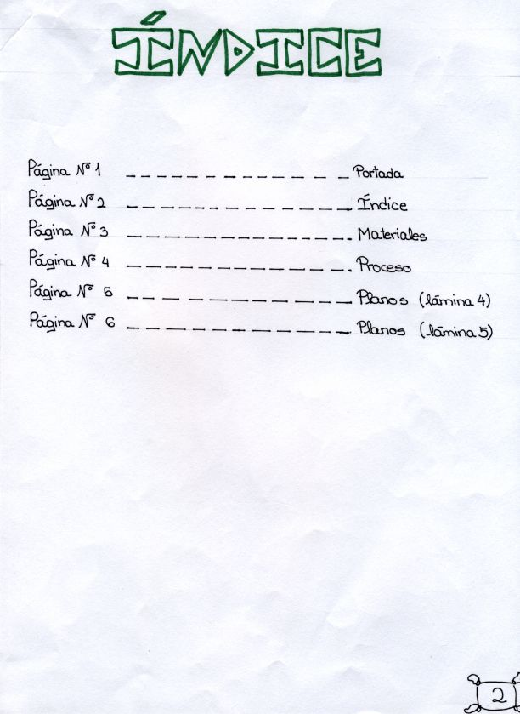

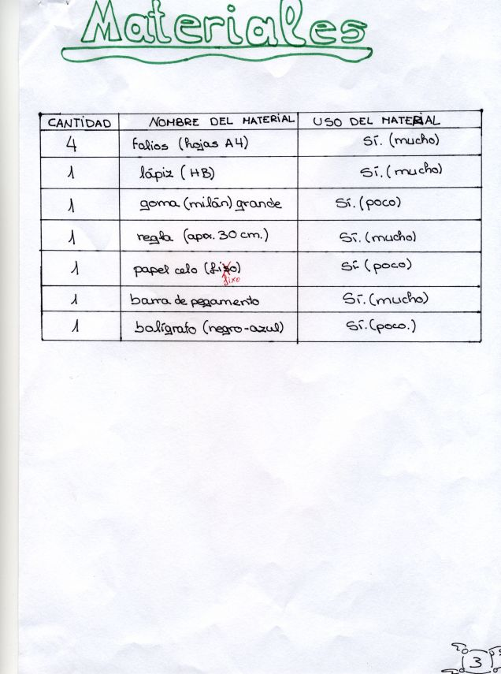

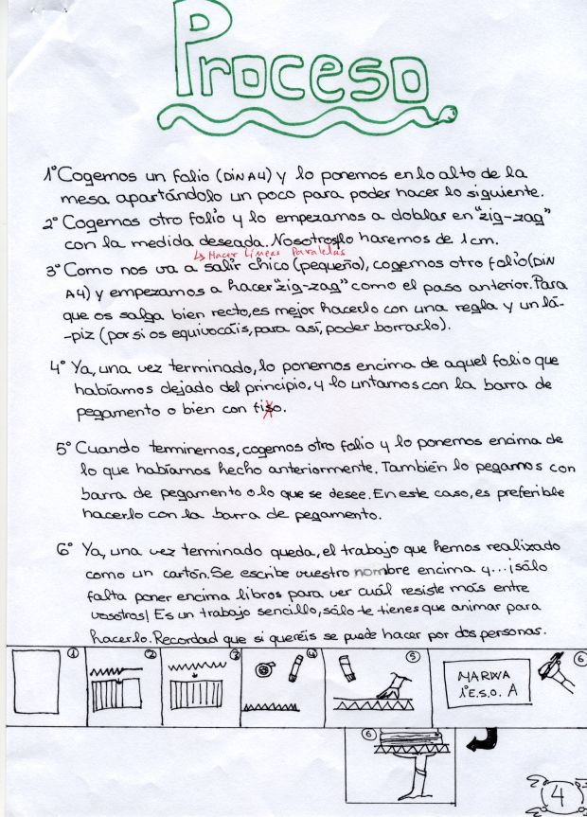

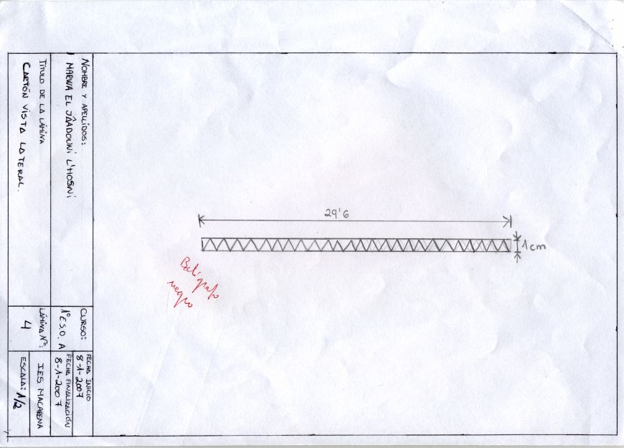
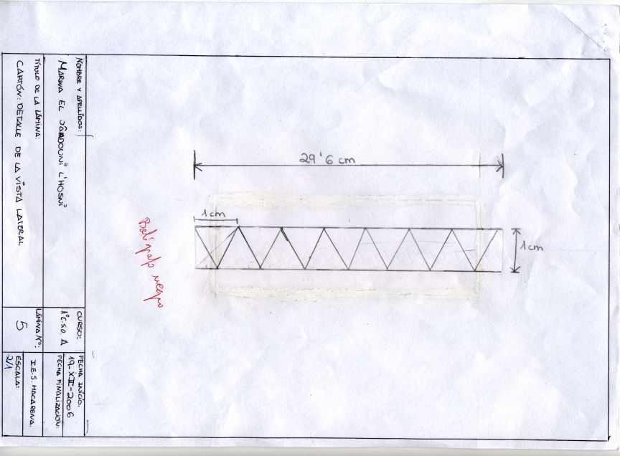
4.- Construction of a bridge.
Now we are going to build a bridge following the model that is on the page below, but we are going to substitute the art straws made of paper for drinking straws. We are going to use straws which have a corrugated part so that it is possible to bend them. The bridge will be 50 cm. long.
See the construction process that we are going to follow in these three pages:
http://www.technologystudent.com/struct1/model1.htm
http://www.technologystudent.com/struct1/model2.htm
http://www.technologystudent.com/struct1/model3.htm

CONSTRUCTION PLAN
4.1.- Construction of 4 triangular structures for the sides, bottom and upper part.
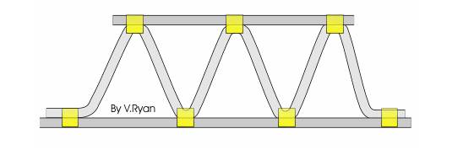
a) Decide the length of the sides of the equilateral triangles that will form the structure and calculate their height. Think of the fact that the resistance of the bridge will be related to it.

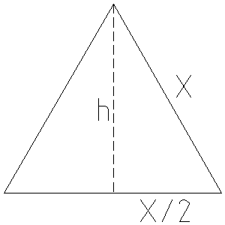

X² = h²+(X/2)² ---------> h² = X² - (X/2)²

b) Once you know the height of the triangle cut a piece of wood to 50 cm. length and width equal to the height of the triangle, plus 2 cm.

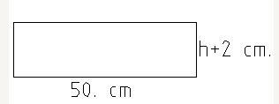

c) On this board, draw two parallel lines separated by a distance equal to the height of the triangle, so that each one will be one cm. away from the border.
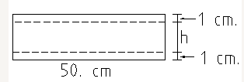

d) Draw marks on these lines at a distance equal to the side of the triangles and make a hole with a drill. The hole must not go though the board.

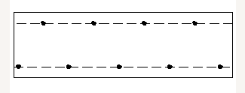

e) Introduce pegs in the holes that have been made.
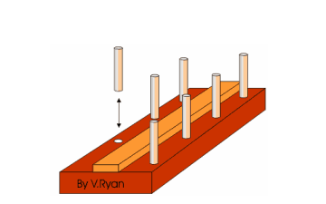

f) Using the pegs, form triangles with the line of straws.

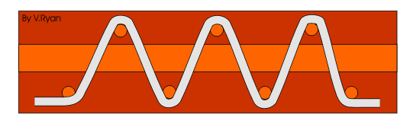
g) Cut out the corrugated section of several straws, and join the straight parts to make the sides. Put them on both sides of the structure and stick them to the triangles with cellotape.

4.2.- Joining the sides.
Join the four sides of the bridge with cellotape and use other straws in the centre to reinforce the structure forming triangles so that the bridge does not bend to the sides.
5.- Test the resistance of the bridge adding weight until it collapses.
6.- Create a project explaining all the processes of construction taking the one on point three as an example.
7.- Sections.
Read the information about sections that is on http://www.technologystudent.com/struct1/beam1.htm

8.- To make a resistant triangular structure follow the same process than in the video:
http://josepanadero.wordpress.com/2012/04/29/el-poder-del-triangulo-2/

Some images from the video:

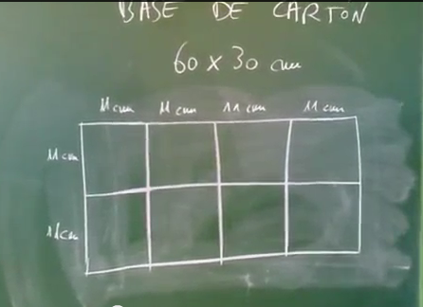

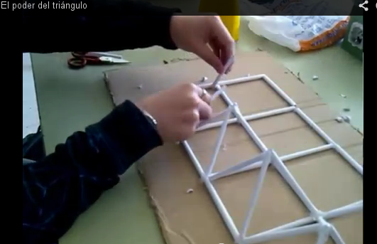

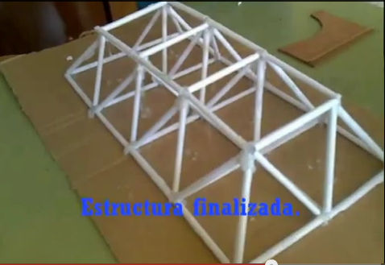

9.- Other examples of resistant structures with paper:
http://www.youtube.com/watch?v=RS6ssfM1AjY

