UNIT 4
TECHNICAL DRAWING: DIMENSIONING
- Dimensions.
Set of lines which indicate the measurements of the objects represented in a drawing. These lines are thinner than the lines representing the object.

Dimensioning elements:
* Extension lines. Perpendicular to the side which gives the measurements.
* Dimension lines. Parallel to the side.
* Arrow heads. At the edges of the dimension lines.
* Figures. They indicate the measurements of the side. They are situated over the dimension line, if this is horizontal, or to its left and in an upwards direction, if it is vertical.

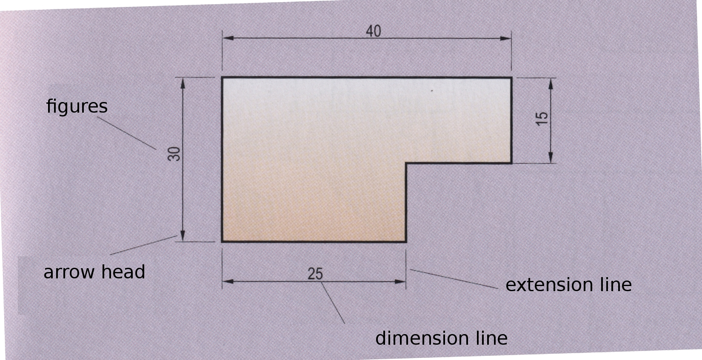
Ed. Donostierra. ESO I (2008). pag.25

http://www.tecno12-18.com/mud/acota/acota.asp (Slides 1-24)

Exercise 1.- On the following figures (shapes), each square represents 5mm. Give the correct dimensions of each one of these drawings.
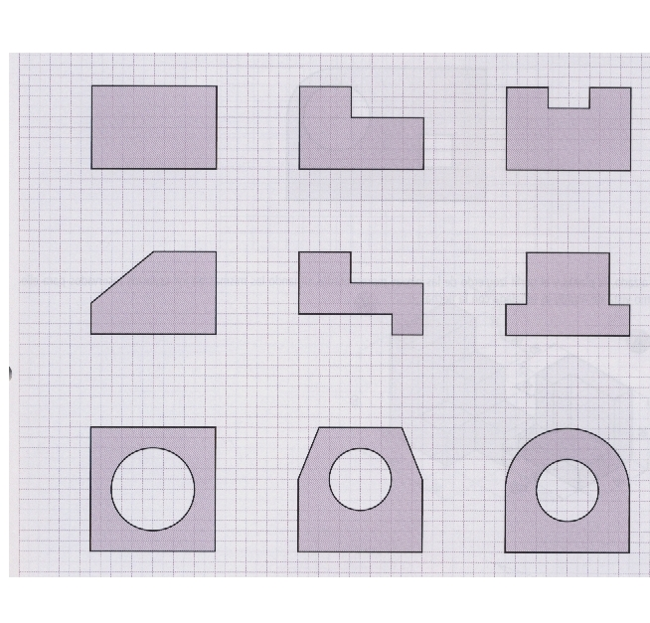

-

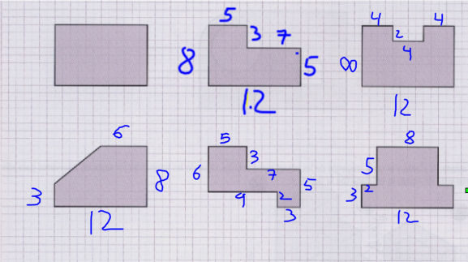

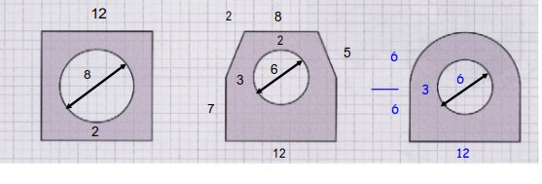
Exercise 2. Draw the following figures using QCad and measure them. First go to Edit > Current Drawing Preferences > Dimensions and copy these figures:
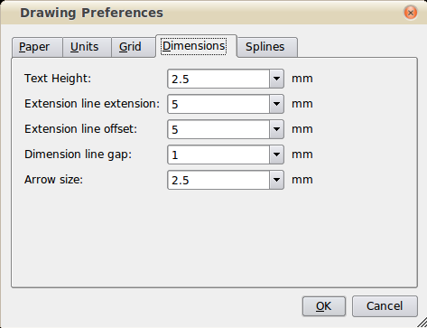

Meaning of each figure:

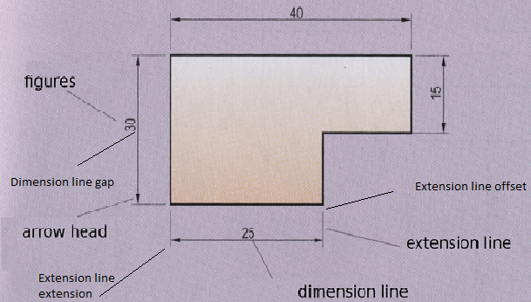

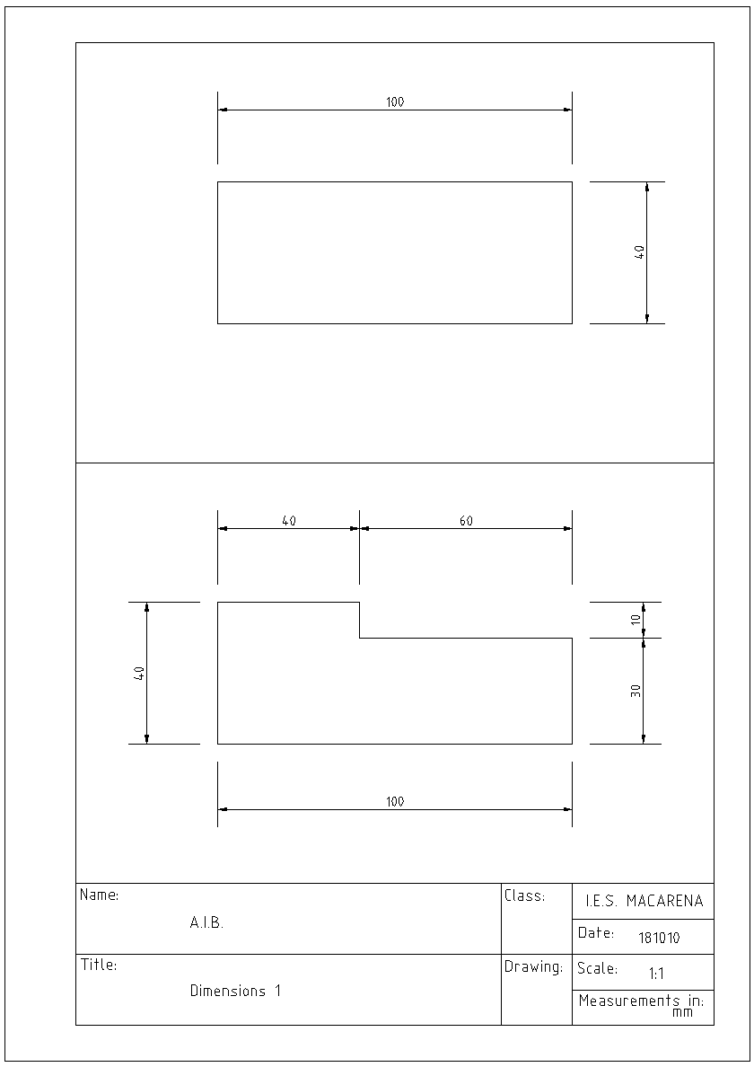

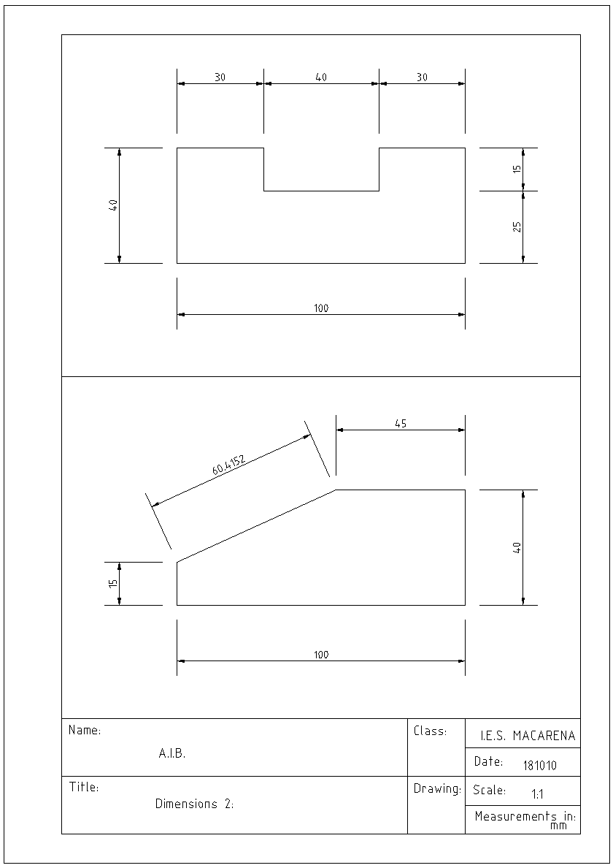

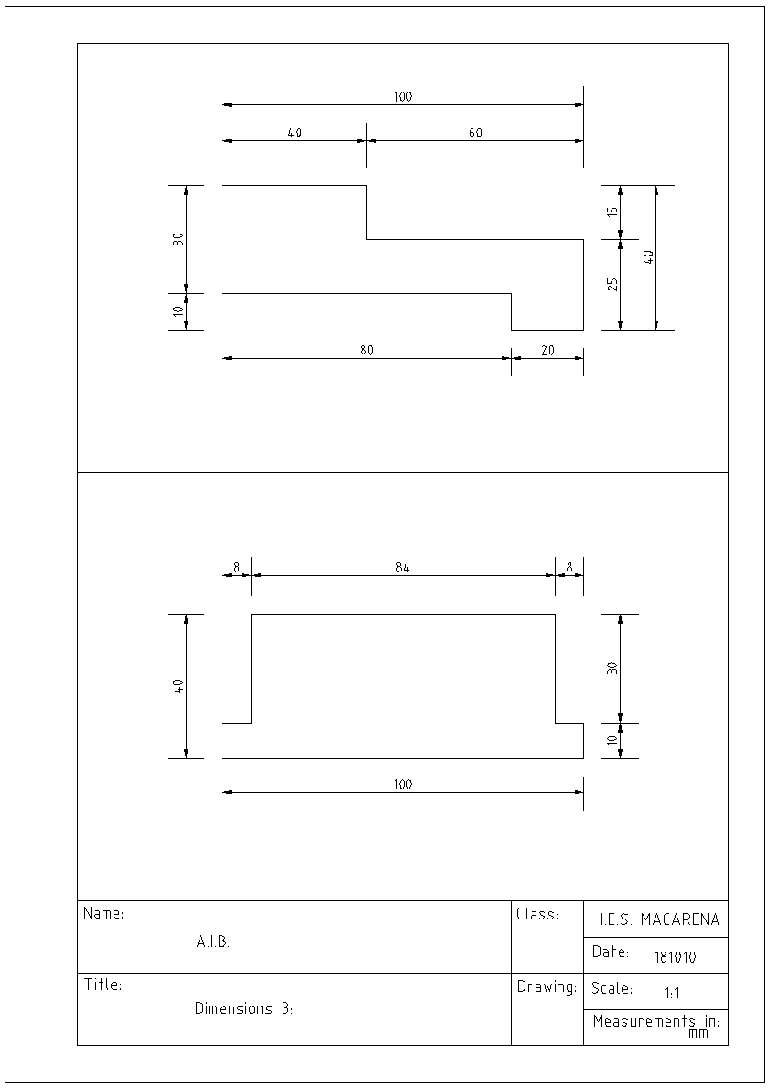

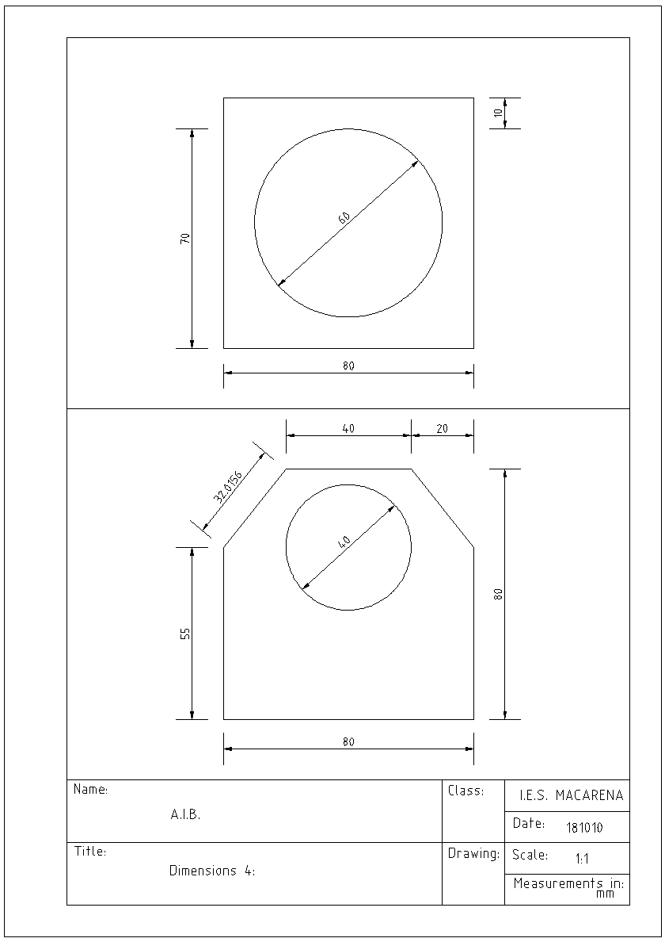

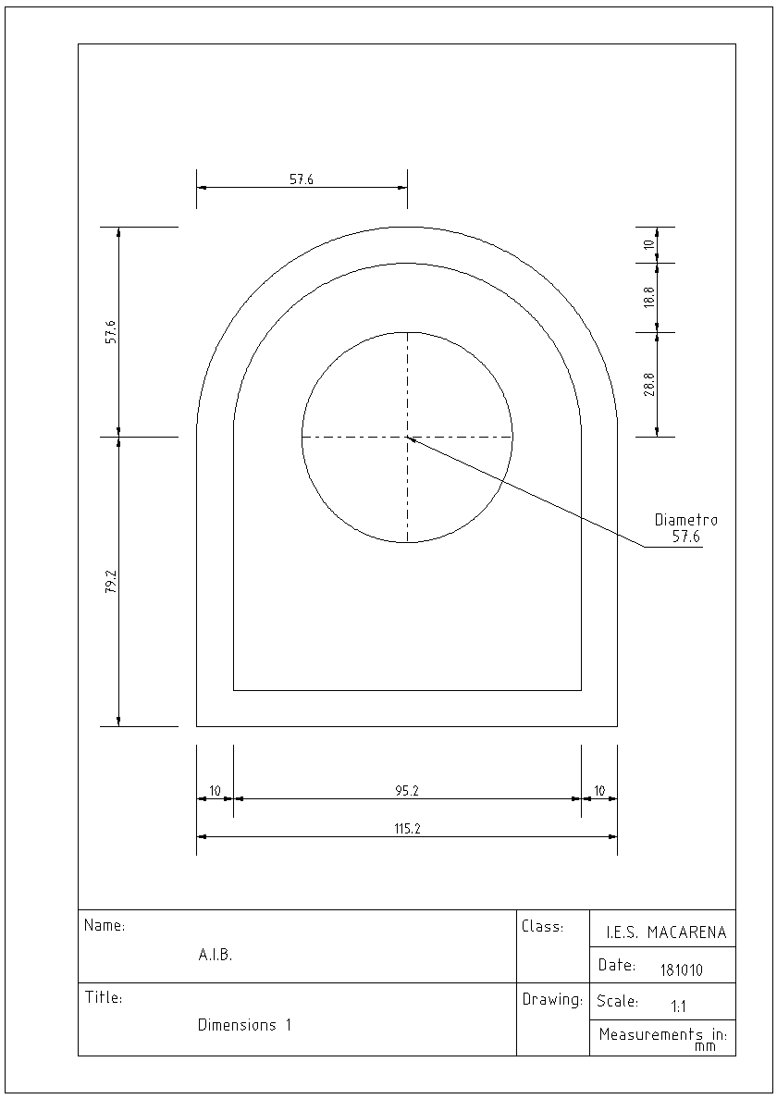

HOW TO TRANSFER A PLAN OF BIG DIMENSIONS TO AN A4 FORMAT WITHOUT CHANGING THE DIMENSIONS.

Qcad Manual: http://www.qcad.org/doc/qcad/2.2/reference/en/
1.- Draw in real dimensions. Change, if necessary from mm. to cm., m. or km.
Edit > Current drawing preferences > Units
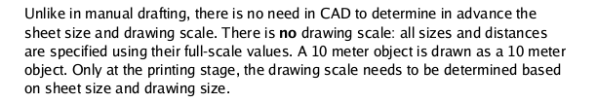

2.- Draw your plan.
3.- Write the dimensions using the tool “dimension”. If the figures are too small or the extension lines are too near the drawing like in the example below,

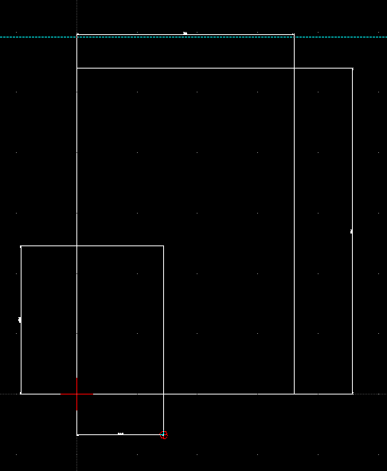

change the settings: Edit > Current drawing preferences > Dimensions

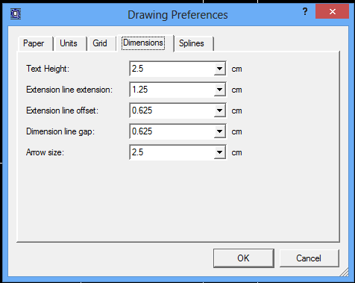

until you can see the dimensions correctly:
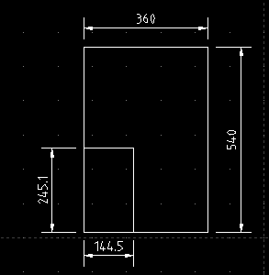

3.- Open a new file: file > new
4.- Change units to mm. Draw the limits of an A4 format, the margins and title block.
5.- Copy the A4 and paste it on the plan you are drawing with real measurements.
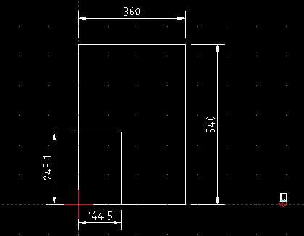
6.- Scale the A4 so that it will be big enough to contain the drawing.

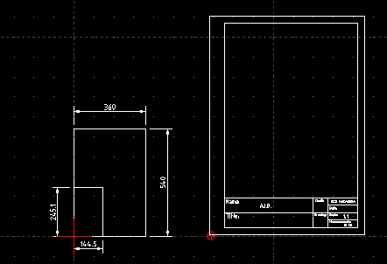

7.- Cut the drawing and paste it inside the A4.

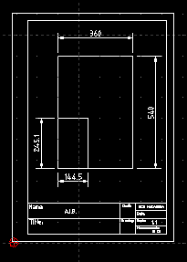

8- Click on Print Preview. Click on “Center to page” and “Fit to page”

DIMENSIONING Errors made during training class. Date: 160211
Wrong or could be improved expression | Correct or better expression
in the paper | on the paper
Perpendicular to dimension line | Perpendicular to the dimension line
substract | subtract
three times longer than they are wide | three times longer that the width

Important to remember:

